* **Actions** When something has to be **added** declared with add_action(). used with do_action().
* **Filters** When something has to be **changed** declared with apply_filters(). used with add_filters().

<https://alecaddd.com/wordpress-101-wordpress-beginner-developers/>

1: Create the basic Structure (index.php, functions.php, header.php, sidebar.php, footer.php and etc.,)

2: How to properly include CSS and JS files

3: How to create custom menus

4: How to use the Post Loop and custom body class

5: How to create Custom and Specialized Page Templates

6: How to add Theme Features with add_theme_support

7: How to add and create Post Formats

WordPress Theme Development Live Session + Q&A

8: How to create Sidebar and Widgets areas

9: Edit the query_posts with WP_Query

10: Filter the WP_Query with categories

WordPress Live Development Session + Q&A – Part 2

11: The single.php file, tags, edit links and comment template

12: Create a custom search form and manage the search results page

13: Create and manage the Pagination in your blog loop

WordPress Live Development Session – Part 3

14: Edit the menu with the Walker Class – Part 1

15: How to print the Blog Info

16: How to create a custom Archive and 404 page

17: How to create Custom Post Type – Part 1

18: How to create Custom Taxonomies – Part 1

19: Custom Taxonomy link and user capabilities

<https://www.taniarascia.com/wordpress-part-three-custom-fields-and-metaboxes/>

<https://www.taniarascia.com/developing-a-wordpress-theme-from-scratch/>

<https://www.taniarascia.com/wordpress-from-scratch-part-two/>

1. Create folder with theme name.
2. Design the logo for your theme.

Color1: #002181

Color 1:

Font name:

Font size:

1. Inside the theme folder create the following files,
   1. Style.css
   2. Functions.php
   3. Index.php
   4. Screenshot.png (dimension: 320px * 233px)
2. Update the following code in style.css as commented text,

/*

Theme name : Amatthx

Theme URI : amathx.com

Author : Deepa

Author URI : google.com

Version : 1.0.0.0

Description: The #1 selling themes of all time that allows you to build virtually any design style.

*/

1. Create the folder setup like below,

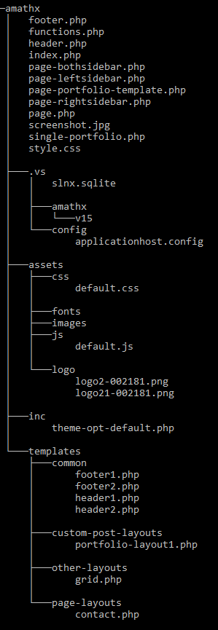

1. Create the loop for post with header and footer in index.php
2. Include menu and post-thumbnails in functions.php

add_theme_support('menus');

add_theme_support('post-thumbnails');

1. Create and register custom menu
2. Enqueue necessary files
3. Include necessary files
4. Create theme submenu
5. Create meta box
6. Add custom fields to the created meta box
7. Save the custom fields
8. Get and display custom fields in the frontend

Logo 1:

Color1: b5121b

Color 1: babcbe

Font: Albertus

Font size: 70

Logo 2:

Color1: 002181

Color 1:

Font:

Font size:

Logo 3:

Color1: EC5F21

Color 1: 08477A

Font:

Font size:

Logo 4:

Color1: EF2A69

Color 1:

Font:

Font size:

Logo 4:

Color1: 6DCDEC

Color2: 449CD9

Color3.: 2C5B99

Color4: 5DBD33

Color5: 2DA041

Color6: E9BF0D

Color7: E53E20

Color8: B4D618

Color9 : E86A19

Font:

Font size: